**Emotion Detection**

**A live interaction to human emotions**

Submitted in partial fulfillment of the requirements for the award of degree of

**BACHELOR OF ENGINEERING**

**IN**

**COMPUTER SCIENCE & ENGINEERING**

**Submitted By:**

ASHUTOSH DIXIT-18021011692

**SCHOOL OF COMPUTING SCIENCE & ENGINEERING**

**Galgotias University, Greater Noida**

**DECLARATION**

We hereby declare that the project entitled - “Emotion Detection”, which is being submitted as a minor project of 5th semester in Computer Science & Engineering to Galgotias University, Greater Noida (U.P) is an authentic record of our genuine work done under the guidance of Assistant Professor **Mr. Gokul Ranjan,** Dept. Computer Science & Engineering, Galgotias University**.**

ASHUTOSH DIXIT

**ACKNOWLEDGEMENT**

We would like to express our sincere gratitude to Mr. Gokul Ranjan, Assistant Professor of the department of Information Technology, whose role as project guide was invaluable for the project. We are extremely thankful for the keen interest he took in advising us, for the books and reference materials provided for the moral support extended to us.

Last but not the least we convey our gratitude to all the teachers for providing us the technical skill that will always remain as our asset and to all non-teaching staff for the gracious hospitality they offered us.

ASHUTOSH DIXIT

**ABSTRACT**

These Human facial expressions convey a lot of information visually rather than articulately. Facial expression recognition plays a crucial role in the area of human-machine interaction. Automatic facial expression recognition system has many applications including, but not limited to, human behavior understanding, detection of mental disorders, and synthetic human expressions. Recognition of facial expression by computer with high recognition rate is still a challenging task. Two popular methods utilized mostly in the literature for the automatic FER systems are based on geometry and appearance. Facial Expression Recognition usually performed in four-stages consisting of pre-processing, face detection, feature extraction, and expression classification. In this project we applied various deep learning methods

(convolutional neural networks) to identify the key seven human emotions: anger, disgust, fear, happiness, sadness, surprise and neutrality.

FEATURES:

• Easy to have analysis of sentiments.

• a simple interface that makes interaction smother and

• help you learn more about our self care.

**Table of Contents**

**S. No** **Particulars**

1. Declaration……………………………………………………2

2. Acknowledgement…………………………………………….3

3. Abstract……………………………….………………….……4

4. Table of content………………………………………….……5

5. List of figures…………………………………………….……6

6. Introduction………………………….. ………………….……7

7. Requirements………..…………………………………….……9

8. Analysis……………………… …………………………...….12

9. Design…………………….…………………………………...15

10. Implementation and Testing of Project Modules……….……..17

11. Limitations and Future Scope…………………………………20

12. Conclusion………………………………………..……………21

13. References ……………………………………….……………22

**List of Figures**

|  |  |  |
| --- | --- | --- |
| **Figure No.** | **Title** | **Page No.** |
| 1 | Basic Human Emotions | 8 |
| 2 | Different Facial Expressions | 11 |
| 3 | Architecture Diagram for Proposed method | 15 |
| 4 | FER CNN Architecture | 17 |
| 5 | Convolutional & Maxpooling Of Neural Network | 18 |

**INTRODUCTION**

**“2018 is the year when machines learn to grasp human emotions”**

-- **Andrew Moore, the dean of computer science at Carnegie Mellon.**

With the advent of modern technology our desires went high and it binds no bounds. In the present era a huge research work is going on in the field of digital image and image processing. The way of progression has been exponential and it is ever increasing. Image Processing is a vast area of research in present day world and its applications are very widespread.

Image processing is the field of signal processing where both the input and output signals are images. One of the most important application of Image processing is Facial expression recognition. Our emotion is revealed by the expressions in our face. Facial Expressions plays an important role in interpersonal communication. Facial expression is a nonverbal scientific gesture which gets expressed in our face as per our emotions. Automatic recognition of facial expression plays an important role in artificial intelligence and robotics and thus it is a need of the generation. Some application related to this include Personal identification and Access control, Videophone and Teleconferencing, Forensic application, Human - Computer

Interaction, Automated Surveillance, Cosmetology and so on.

The objective of this project is to develop Automatic Facial Expression Recognition System which can take human facial images containing some expression as input and recognize and classify it into seven different expression class such as :

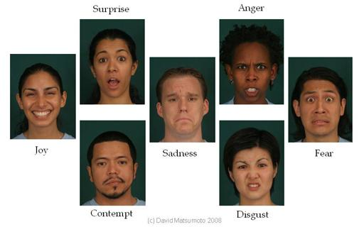**I. Neutral 1.**

**II. Angry**

**III. Disgust**

**IV. Fear**

**V. Happy**

**VI. Sadness**

**VII. Surprise**

Several Projects have already been done in this fields and our goal will not only be to develop an Automatic Facial Expression Recognition System but also improving the accuracy of this system compared to the other available systems.

**REQUIREMENTS**

As the project will be developed in python, so we will use Anaconda for Python and Spyder.

**Anaconda**: It is a free and open source distribution of the Python and R programming languages for data science and machine learning related applications (large-scale data processing, predictive analytics, scientific computing), that aims to simplify package management and deployment.

**Spyder**: Spyder is an open source cross-platform integrated development environment (IDE) for scientific programming in the Python language. Spyder integrates NumPy, SciPy, Matplotlib and IPython, as well as other open source software.

**Features include**:

1. Editor with syntax highlighting and introspection for code completion

2. Support for multiple Python consoles (including IPython)

3. The ability to explore and edit variables from a GUI

**Hardware Interfaces:**

1. Processor: Intel CORE i5 processor with minimum 2.9 GHz speed.

2. RAM: Minimum 4 GB.

3. Hard Disk: Minimum 500 GB

**Software Interfaces:**

1. Microsoft Word 2003

2. Database Storage: Microsoft Excel

3. Operating System: Windows10

**Feasibility of Proposed system:**

1) It has the ability to leverage existing image

acquisition equipment.

2) It can search against static images such as driver’s license photographs.

3) It is the only biometric able to operate without user cooperation.

4) It has the capability to strengthen our healthcare system as well as improve law and

order in the society.

Also,

To help Patients or physically and mentally challenged people • Getting automatic

feedback : Prominently used in marketing sector

• E-learning

• Gaming

• Improving Law and Order

• Smart health-care

• Driver Fatigue Monitoring

• Security Systems

• Psychology and Computer Vision

• Interactive Computer Simulations/designs.

**Objective:**

Human facial expressions can be easily classified into 7 basic emotions: happy, sad, surprise, fear, anger, disgust, and neutral. Our facial emotions are expressed through activation of specific sets of facial muscles. These sometimes subtle, yet complex, signals in an expression often contain an abundant amount of information about our state of mind. Through facial emotion recognition, we are able to measure the effects that content and services have on the audience/users through an easy and low-cost procedure. For example: retailers may use these metrics to evaluate customer interest.

Healthcare providers can provide better service by using additional information about patients' emotional state during treatment. Entertainment producers can monitor audience engagement in events to consistently create desired content.

Humans are well-trained in reading the emotions of others, in fact, at just 14 months old, babies can already tell the difference between happy and sad. But can computers do a better job than us in accessing emotional states? To answer the question, We are going to design deep learning neural network that gives machines the ability to make inferences about our emotional states. In other words, we give them eyes to see what we can see. Several Projects have already been done in this fields and our goal will not only be to develop a Automatic Facial Expression Recognition System but also improving the accuracy of this system compared to the other available systems

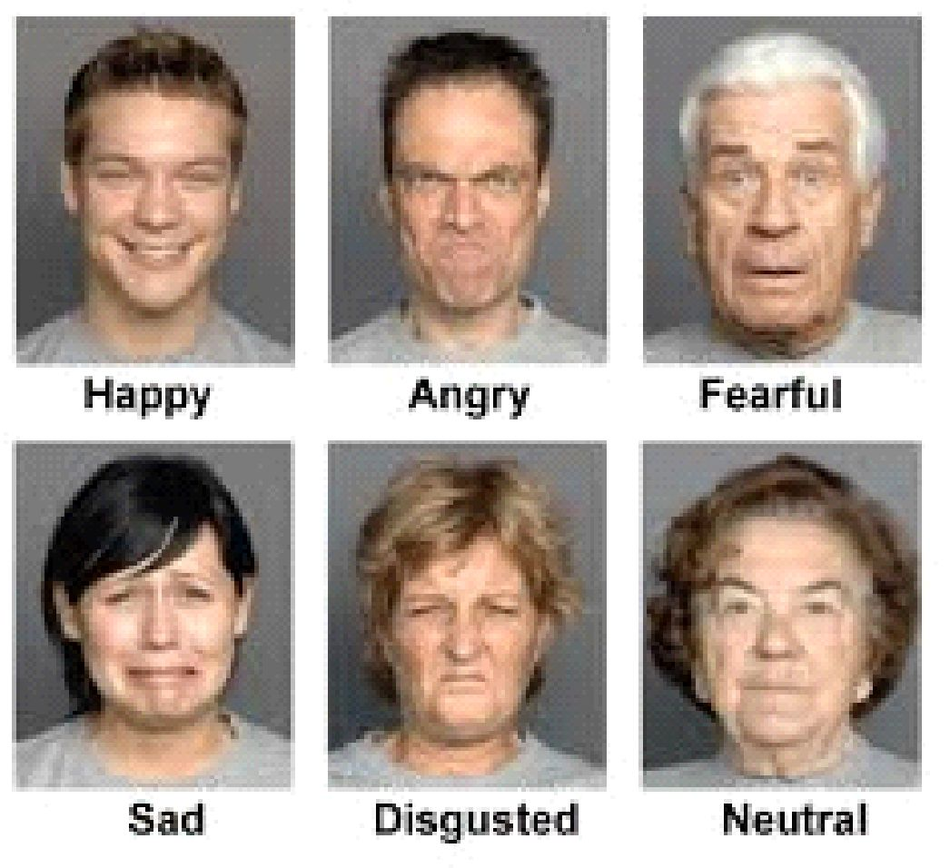

**ANALYSIS**

**LITERATURE STUDY**

As per various literature surveys it is found that for implementing this project four basic steps are required to be performed.

1. Preprocessing

2. Face registration

3. Facial feature extraction

4. Emotion classification

Description about all these processes are given below:

**a) Emotion Classification:** In the third step, of classification, the algorithm attempts to classify the given faces portraying one of the seven basic emotions. Paul Ekmanan American psychologist and professor who is a pioneer in the study of emotions and their relation to facial expressions. He has created an "atlas of emotions" with more than ten thousand facial expression.

**b)Preprocessing:** Preprocessing is a common name for operations with images at the lowest level of abstraction both input and output are intensity images. Most preprocessing steps that are implemented are –

a. Reduce the noise

b. Convert The Image To Binary/Grayscale.

c. Pixel Brightness Transformation.

d. Geometric Transformation.

**c) Facial Feature Extraction :** Facial Features extraction is an important step in face recognition and is defined as the process of locating specific regions, points, landmarks, or curves/contours in a given 2-D image or a 3D range image. In this feature extraction step, a numerical feature vector is generated from the resulting registered image. Common features that can be extracted area. Lips b. Eyes c. Eyebrows d. Nose tip.

**d) Face Registration**: Face Registration is a computer technology being used in a variety of applications that identifies human faces in digital images. In this face registration step, faces are first located in the image using some set of landmark points called “face localization” or “face detection”. These detected faces are then geometrically normalized to match some template image in a process called “face registration”.

**COMPARATIVE STUDY**

Different approaches which are followed for Facial Expression Recognition:

**Neural Network Approach**: The neural network contained a hidden layer with neurons. The approach is based on the assumption that a neutral face image corresponding to each image is available to the system. Each neural network is trained independently with the use of on-line back propagation.

**Principal of Component Analysis**: Principal component analysis (PCA) is a statistical procedure that uses an orthogonal transformation to convert a set of observations of possibly correlated variables into a set of values of linearly uncorrelated variable called Principal Components.

**Gabor Filter**: In image processing, a Gabor filter, named after Dennis Gabor, is a linear filter used for texture analysis, which means that it basically analyses whether there are any specific frequency content in the image in specific directions in a localized region around the point or region of analysis.

**Support Vector Machine**: In machine learning, support vector machines (SVMs, also support vector networks) are supervised learning models with associated learning algorithms that analyze data used for classification and regression analysis.

**Training & Testing Database**: In machine learning, the study and construction of algorithms that can learn from and make predictions on data is a common task. Such algorithms work by making datadriven predictions or decisions, through building a mathematical model from input data.

**PLANNING:**

Facial emotion recognition is a process performed by humans or computers, which consists of: 1.Locating faces in the scene (e.g., in an image; this step is also referred to as face detection),.

2. Extracting facial features from the detected face region (e.g., detecting the shape of facial components or describing the texture of the skin in a facial area; this step is referred to as facial feature extraction).

3. Analyzing the motion of facial features and/or the changes in the appearance of facial features and classifying this information into some facial-expressions interpretative categories such as facial muscle activations like smile or frown, emotion (affect)categories like happiness or anger, attitude categories like (dis)liking or ambivalence, etc.(this step is also referred to as facial expression interpretation).

The steps we will follow while developing this project are-:

1. Analysis of the problem statement.

2. Gathering of the requirement specification

3. Analysation of the feasibility of the project.

4. Development of a general layout.

5. Going by the journals regarding the previous related works on this field. 6. Choosing the method for developing the algorithm.

7. Analyzing the various pros and cons.

8. Starting the development of the project

9. Installation of software like ANACONDA.

10. Developing an algorithm.

11. Analysation of algorithm by guide.

12. Coding as per the developed algorithm in PYTHON.

**DESIGN:**

**Architecture Diagram for Proposed method:**

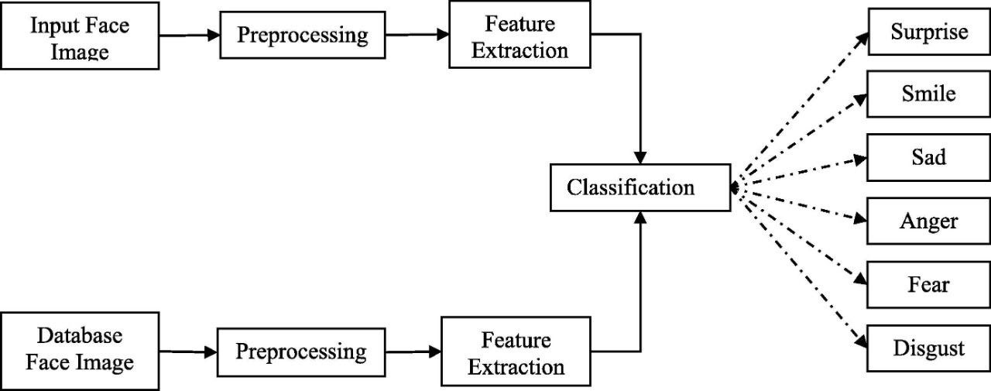

**ALGORITHM:**

**Step 1**: Collection of a data set of images (faces each labeled with one of the 7 emotion classes: anger, disgust, fear, happiness, sadness, surprise, and neutral.

**Step 2**: Pre-processing of images.

**Step 3**: Detection of a face from each image.

**Step 4**: The cropped face is converted into grayscale images.

**Step 5**: The pipeline ensures every image can be fed into the input layer as a (1, 48, 48) numpy array.

**Step 5**: The numpy array gets passed into the Convolution2D layer.

**Step 6**: Convolution generates feature maps.

**Step 7**: Pooling method called MaxPooling2D that uses (2, 2) windows across the feature map only keeping the maximum pixel value.

**Step 8**: During training, Neural network Forward propagation and backward propagation performed on the pixel values.

**Step 9**: The Softmax function presents itself as a probability for each emotion class. The model is able to show the detail probability composition of the emotions in the face.

**IMPLEMENTATION & TESTING OF PROJECT MODULES**:

**The Database:**

As we were exploring the dataset, we discovered an imbalance of the “disgust” class

compared to many samples of other classes. We decided to merge disgust into anger given that they both represent similar sentiment. The resulting is a 6-class, balanced dataset, that contains angry, fear, happy, sad, surprise, and neutral. Now we‟re ready to train.

**The Mode:**

Deep learning is a popular technique used in computer vision. We chose

Convolutional Neural Network (CNN) layers as building blocks to create our model

architecture. CNNs are known to imitate how the human brain works when analyzing

visuals. We have used a picture of Mr. Bean as an example to explain how images are

fed into the model, because who doesn’t love Mr. Bean?

A typical architecture of a convolutional neural network contain an input layer, some convolutional layers, some dense layers (aka. fully-connected layers), and an output

layer . These are linearly stacked layers ordered in sequence. In Keras, the model is

created as Sequential() and more layers are added to build architecture.

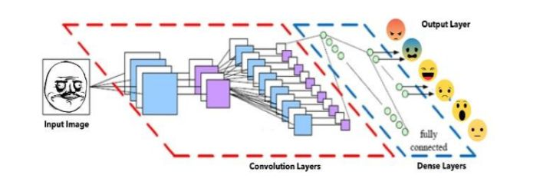

**Input Layer:**

The input layer has pre-determined, fixed dimensions, so the image must be pre-processed before it can be fed into the layer This step greatly reduces the dimensions compared to the original RGB format with three color dimensions.

**Convolutional Layers:**

The numpy array gets passed into the Convolution2D layer where we specify the number of filters as one of the hyper parameters. The set of filters (aka. kernel) are unique with randomly generated weights. Each filter, receptive field, slides across the original image with shared weights to create a feature map. Convolution generates feature maps that represent how pixel values are enhanced, for example, edge and pattern detection. A feature map is created by applying filter 1 across the entire image. Other filters are applied one after another creating a set of feature maps.

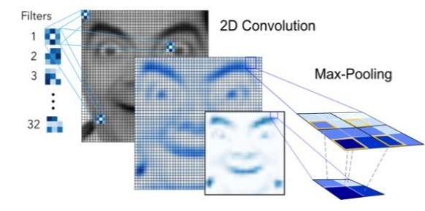

**Dense Layers:**

The dense layer (aka fully connected layers), is inspired by the way neurons

transmit signals through the brain. It takes a large number of input features and

transform features through layers connected with trainable weights.

Back propagation starts from evaluating the difference between prediction and

true value, and back calculates the weight adjustment needed to every layer before.

We can control the training speed and the complexity of the architecture by

tuning the hyper-parameters, such as learning rate and network density.

**Output Layer:**

Instead of using sigmoid activation function, we used softmax at the output

layer. This output presents itself as a probability for each emotion class.Therefore, the model is able to show the detail probability composition of the emotions in the face. As later on, you will see that it is not efficient to classify human facial expression as only a single emotion. Our expressions are usually much complex and contain a mix of emotions that could be used to accurately describe a particular expression.

**Model Validation:**

Performance As it turns out, the final CNN had a validation accuracy of 58%. This

actually makes a lot of sense. Because our expressions usually consist a combination

of emotions, and only using one label to represent an expression can be hard. In this

case, when the model predicts incorrectly, the correct label is often the second

most likely emotion.

**LIMITATIONS:**

Facial expression analysis has a major drawback – mimics could be to some extent controlled by humans and therefore the **recognition** results might be intentionally or unintentionally falsified.

When trying to read a person’s emotions, context is everything. If someone cries at the birth of their child, it’s likely to be out of happiness, not because they’re upset. If a footballer puffs out their chest and bares their teeth after they score a goal, they’re celebrating a victory, not squaring up for a fight. “So it’s only valuable if an algorithm can say, ‘I see this person is in a trial and I know what’s going on in that situation’. Then you might be able to make valid inferences,”

We are deliberately regulating the signals we send to others. This has repercussions for lie-detection technology in particular. If the system’s goal is to catch someone in a lie and that person knows they’re being watched, then the accuracy of that result will inevitably be affected.

**FUTURE SCOPE:**

It is important to note that there is no specific formula to build a neural network that would guarantee to work well. Different problems would require different network architecture and a lot of trail and errors to produce desirable validation accuracy. This is the reason why neural nets are often perceived as "black box algorithms.".

In this project we got an accuracy of almost 70% which is not bad at all comparing all the previous models. But we need to improve in specific areas like-

* number and configuration of convolutional layers
* number and configuration of dense layers
* dropout percentage in dense layers

But due to lack of highly configured system we could not go deeper into dense neural network as the system gets very slow and we will try to improve in these areas in future. We would also like to train more databases into the system to make the model more and more accurate but again resources becomes a hindrance in the path and we also need to improve in several areas in future to resolve the errors and improve the accuracy.

**CONCLUSION:**

In this case, when the model predicts incorrectly, the correct label is often the second most likely emotion. The facial expression recognition system presented in this research work contributes a resilient face recognition model based on the mapping of behavioral characteristics with the physiological biometric characteristics.

The physiological characteristics of the human face with relevance to various expressions such as happiness, sadness, fear, anger, surprise and disgust are associated with geometrical structures which restored as base matching template for the recognition system. The behavioral aspect of this system relates the attitude behind different expressions as property base. The property bases are alienated as exposed and hidden category in genetic algorithmic genes.

The gene training set evaluates the expressional uniqueness of individual faces and provide a resilient expressional recognition model in the field of biometric security. The design of a novel asymmetric cryptosystem based on biometrics having features like hierarchical group security eliminates the use of passwords and smart cards as opposed to earlier cryptosystems. It requires a special hardware support like all other biometrics system. This research work promises a new direction of research in the field of asymmetric biometric cryptosystems which is highly desirable in order to get rid of passwords and smart cards completely.

Experimental analysis and study show that the hierarchical security structures are effective in geometric shape identification for physiological traits.

**REFERENCES**

* https://towardsdatascience.com/emotion-detection-a-machine-learning-project-f7431f652 b1f
* https://www.rcciit.org/students_projects/projects/it/2018/GR8.pdf
* https://web.stanford.edu/class/ee368/Project_Autumn_1617/Reports/report_pao.pdf